8th December 2019

**Title: Emirati Wins a Range Rover at Dubai Duty Free Finest Surprise Draw**

**Summary:** Dubai Duty Free and The Irish Village returned as one of the sponsors of the 50th Emirates Airline Dubai Rugby Sevens which took place on 5th to 7th December at The Sevens Stadium.

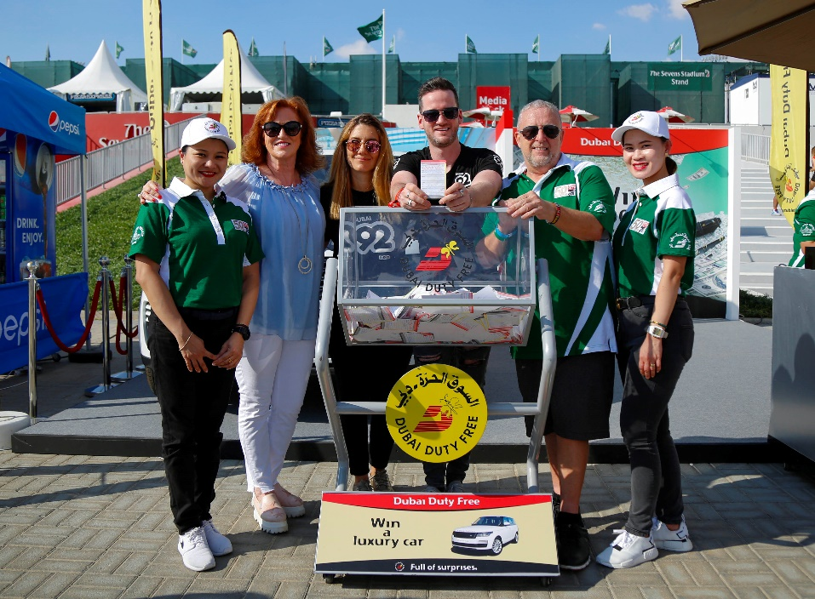

**Dubai Duty Free Senior Vice President – Marketing Sinead El Sibai along with Dave Cattanach, General Manager – The Irish Village Complex conducted the Dubai Duty Free Finest Surprise draw for a Range Rover together with Dubai 92 presenters.**

Dubai Duty Free and The Irish Village returned as one of the sponsors of the 50th Emirates Airline Dubai Rugby Sevens which took place on 5th to 7th December at The Sevens Stadium.

On Friday, 6th November, Dubai Duty Free conducted a Finest Surprise Draw to win a luxury car, a Range Rover HSE 340 PS (Fuji White), in Series 1736. The winner was an Emirati national, Mr. Mohammed Alblooshi, with winning ticket no. 0712.

Mr Alblooshi, a 37-year-old father of five, has been participating in Dubai Duty Free promotions for two years now, said: ” I am delighted that I have finally won a car after two years of trying my luck. I had two tickets for this series which I bought from the Finest Surprise counter located at Le Meridien Hotel in November.“ Mr Alblooshi is a businessman based in Dubai and thanked Dubai Duty Free for his amazing win.

The Dubai Duty Free Finest Surprise draw was conducted by Sinead El Sibai, Senior Vice President – Marketing and Dave Cattanach, General Manager – The Irish Village Complex together with Dubai 92 presenters..

* Ends -